**PROJECT REPORT**

THE SMART DOOR..!!

**IOT :**

The **Internet of Things** (**IoT**) is the network of physical devices, vehicles, home appliances and other items [embedded](https://en.wikipedia.org/wiki/Embedded_system) with [electronics](https://en.wikipedia.org/wiki/Electronics), [software](https://en.wikipedia.org/wiki/Software), [sensors](https://en.wikipedia.org/wiki/Sensor), [actuators](https://en.wikipedia.org/wiki/Actuator), and [connectivity](https://en.wikipedia.org/wiki/Internet_access) which enables these objects to connect and exchange [data](https://en.wikipedia.org/wiki/Data).[[1]](https://en.wikipedia.org/wiki/Internet_of_things#cite_note-Linux_Things-1)[[2]](https://en.wikipedia.org/wiki/Internet_of_things#cite_note-Linux_21OSP-2)[[3]](https://en.wikipedia.org/wiki/Internet_of_things#cite_note-ITU-3) Each thing is uniquely identifiable through its embedded [computing](https://en.wikipedia.org/wiki/Computing) system but is able to inter-operate within the existing [Internet](https://en.wikipedia.org/wiki/Internet) infrastructure.



The IoT allows objects to be sensed or controlled remotely across existing network infrastructure,[[7]](https://en.wikipedia.org/wiki/Internet_of_things#cite_note-7) creating opportunities for more direct integration of the physical world into computer-based systems, and resulting in improved efficiency, accuracy and economic benefit in addition to reduced human intervention. When IoT is augmented with sensors and actuators, the technology becomes an instance of the more general class of cyber-physical systems which also encompasses technologies such as [smart grids](https://en.wikipedia.org/wiki/Smart_grid), [virtual power plants](https://en.wikipedia.org/wiki/Virtual_power_plant), [smart homes](https://en.wikipedia.org/wiki/Smart_home), [intelligent transportation](https://en.wikipedia.org/wiki/Intelligent_transportation) and [smart cities](https://en.wikipedia.org/wiki/Smart_city).

**Smart door :**

A device that is always connected to internet, to have a remote control of your door, simply using your smartphone!

The purpose of this device is to help people to have easily access at their house and to have a remote control of a door. The focus of this project is about the domestic use of this product. The idea of a smart door is not new, however, most of these ideas revolve around using some sort of ‘key’ to unlock the door, such as communicating with the phone via Bluetooth, biometrics, or a keypad, through the integration of a smart doorbell and app.

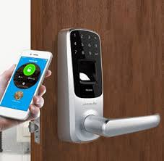

HOW TO SOLVE:

CASE 1: We developed a simple application for Android that allow the owner to open the door, with just few clicks, when he enters in the range of the camera. We would use an App like a real key!

CASE 2 : We use Raspberry Pi as a notification receiver, and the camera as a transmitter. When the Raspberry catches the signal, it performs an action. We would use a camera like a real key!

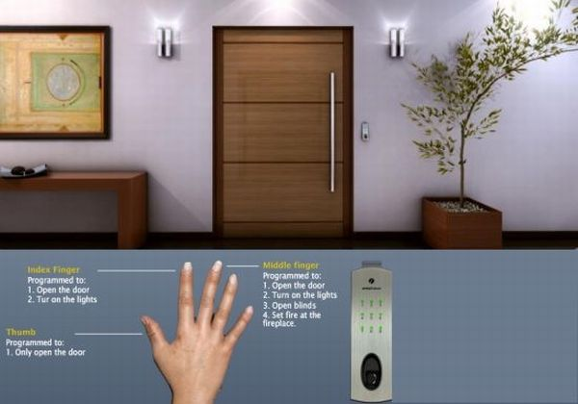

The designing of the above smart door consists of hardware and software requirements which include basic shield, raspberry PI, Logitech camera, Connecting wires, Node-red, MQTT, MIT app inventor etc.

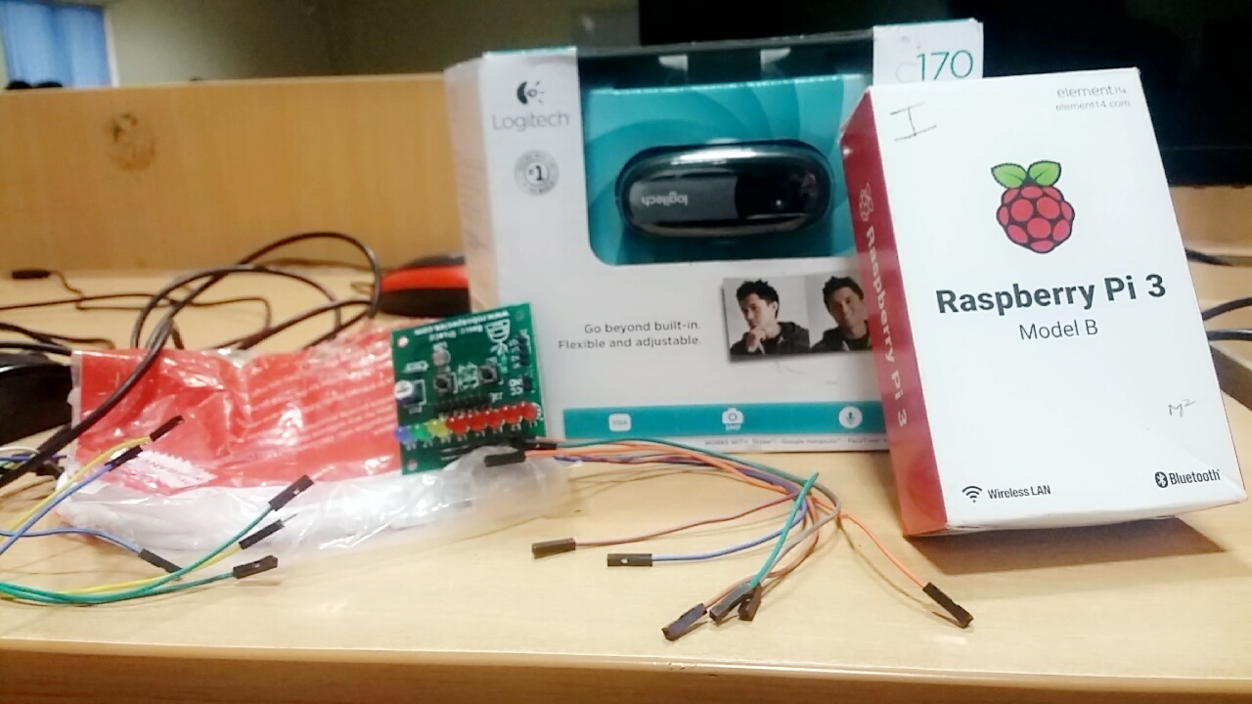

Working ;

Firstly the owner’s fingerprints are already stored in the cloud database during installation. So once their fingerprint is scanned, they can perform operations of locking and unlocking either through their fingerprints or from their smart phones. In case an outsider visits and rings the bell, the notification is sent to the owner’s device and the cloud simultaneously where the owner receives a beep to his device asking to enable the camera. Parallelly , the information is stored in the cloud database for further references. After which the owner can grant access or reject the access of the visitors accordingly.

This is more useful for persistent cases like thefts, robbery, burglary, emergencies etc.



We can even inculcate the feature of visual recognition so that if any unusual activity is being recorded, the owner immediately receives an emergency notification warning.

FUNCTIONS AND FEATURES :

• Ping user with picture of door when bell is rung via camera

• Allow user to view video feed at door through an app

• Allow user to unlock the door via app by using the door controller

• All channels of communication fulfils security standards

• All hardware on door, such as the camera, doorbell, microcontroller, and door lock are free from physical tampering.

• Door lock also works with a physical key

• An app that is easy for users to use and meets outlined standards

Home Security system for automatic doors provide advance security of today’s standards for house owners. Since our proposed system is built on wireless sensor network, it is flexible and easily installable system without any overhead such as prior and careful planning, construction work etc.